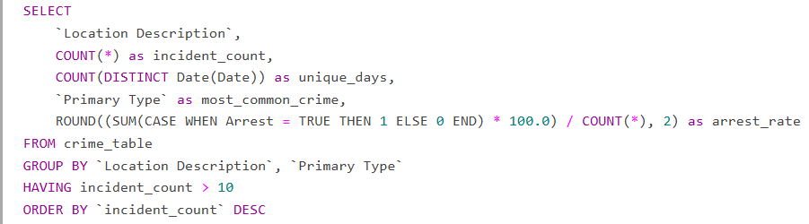

CHICAGO CRIME ANALYSIS IN SQL

Repeat Crime Location Pattern

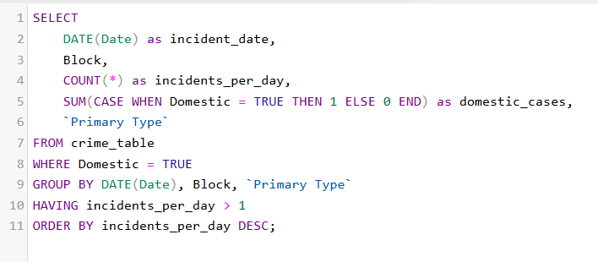

Domestic Violence Increase Patterns

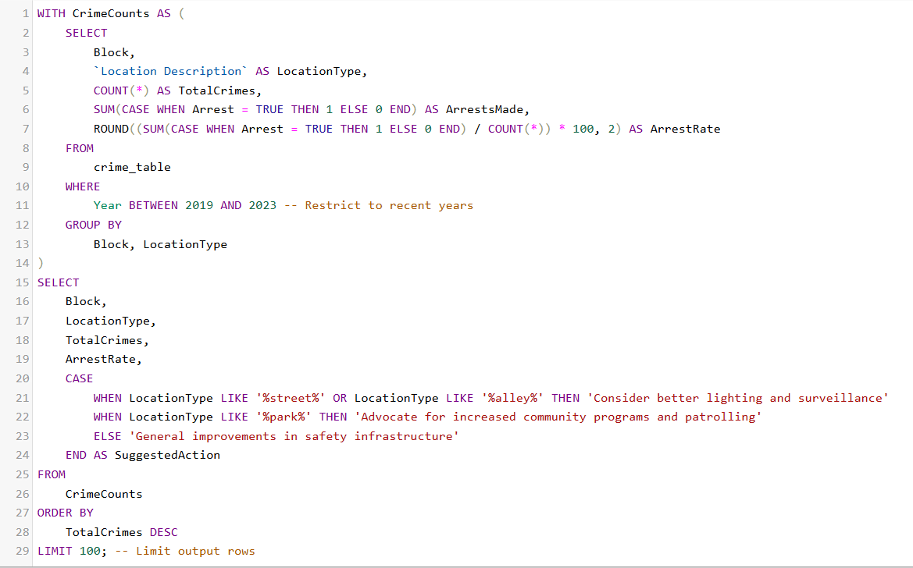

Urban Planning and Policy Development

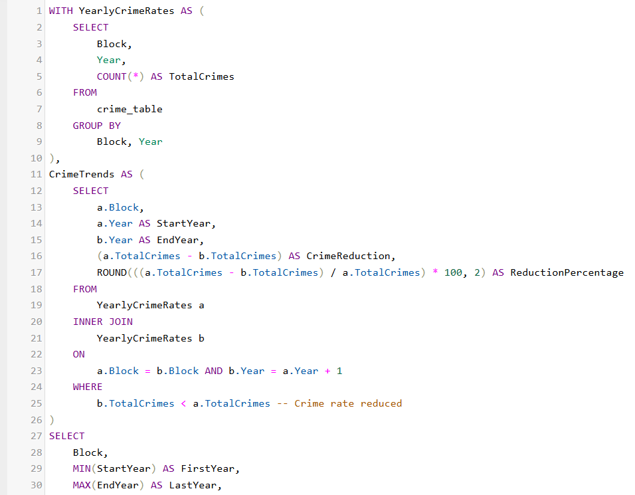

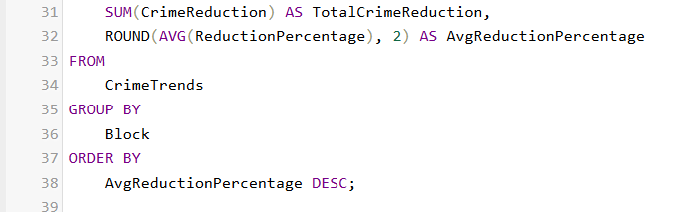

Preventive Analysis

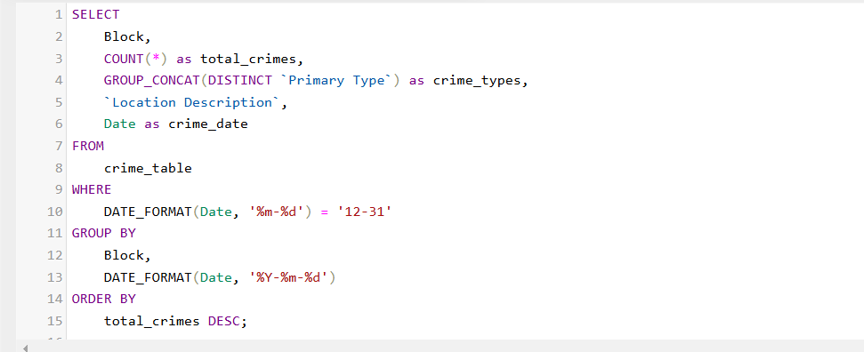

Crime Analysis on December 31

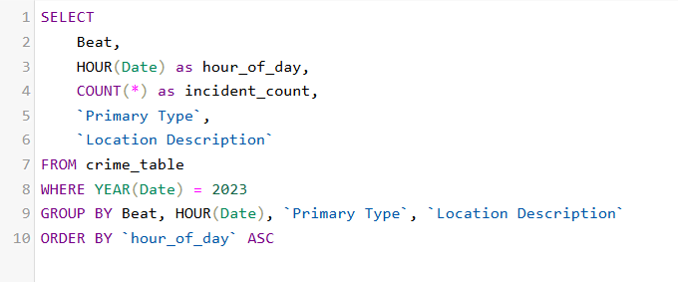

Beat Workload Distribution

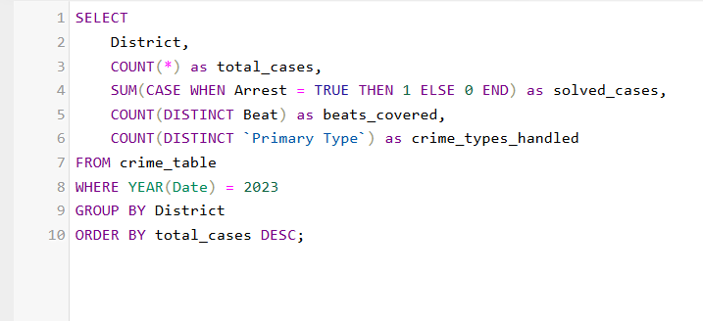

District Performance Metrics

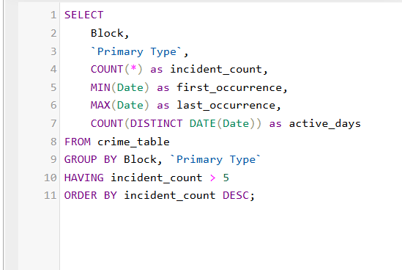

Serial Pattern Analysis

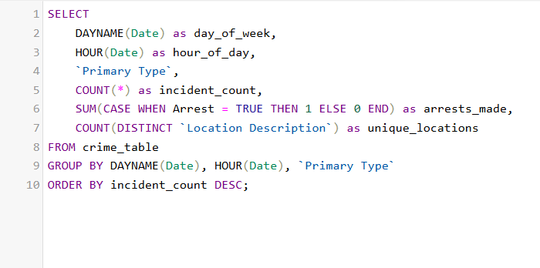

Time-Based Risk Assessment

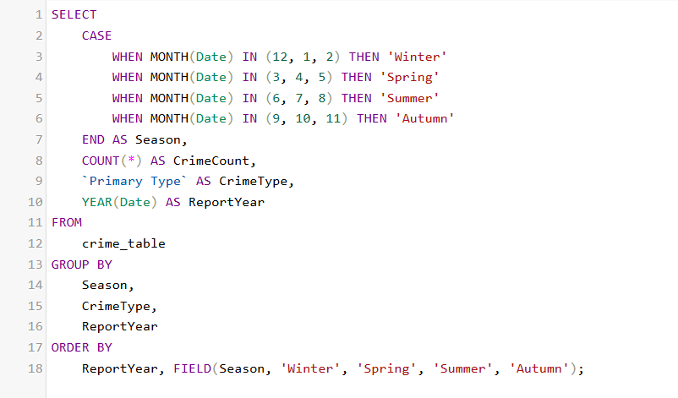

Seasonal Analysis